***TEAM LEADER:***

Manan Sharma

18BCI0132

***TEAM NAME:***

***Mendit (System application name)***

***TEAM MEMBERS:***

|  |  |
| --- | --- |
| Name | Register number |
| Manan Sharma | 18BCI0132 |
| Rakshith Sachdev | 18BCI0109 |
| Ayush Rana | 18BCE2305 |
| Hrithik Ahuja | 18BCE2154 |
| Rohan Allen | 18BCI0247 |

***PROJECT TITLE:***

***Mendit: An ML based web platform to mediate employers and employees (unskilled as well as skilled)***

***EXPECTED OUTCOMES:***

1. Providing a medium to common people to easily search and hire workers in their locality within an optimization between user’s budget vs skill of workers and handymen services.

2. Provide a platform and a resourceful medium to workers who aren’t able to find regular work in their locality itself, with contract-based or part time jobs as an additional source of income.

***DURATION:***

Time line of the project represented in form of a Gantt Chart till first two reviews:

Totally we would require around 70-80 ( 2- 2.5 months) days for full completion of testing (what we have approximated now it can also be less than this if we use off the shelf design model for our software development) and then we would require some time for documentation as well.

**ACTIVITIES**

***DAYS***

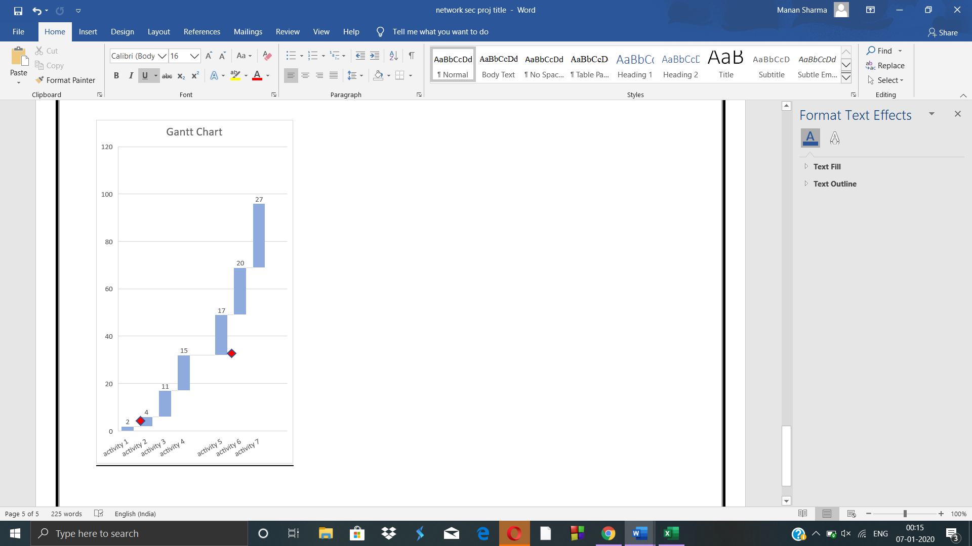

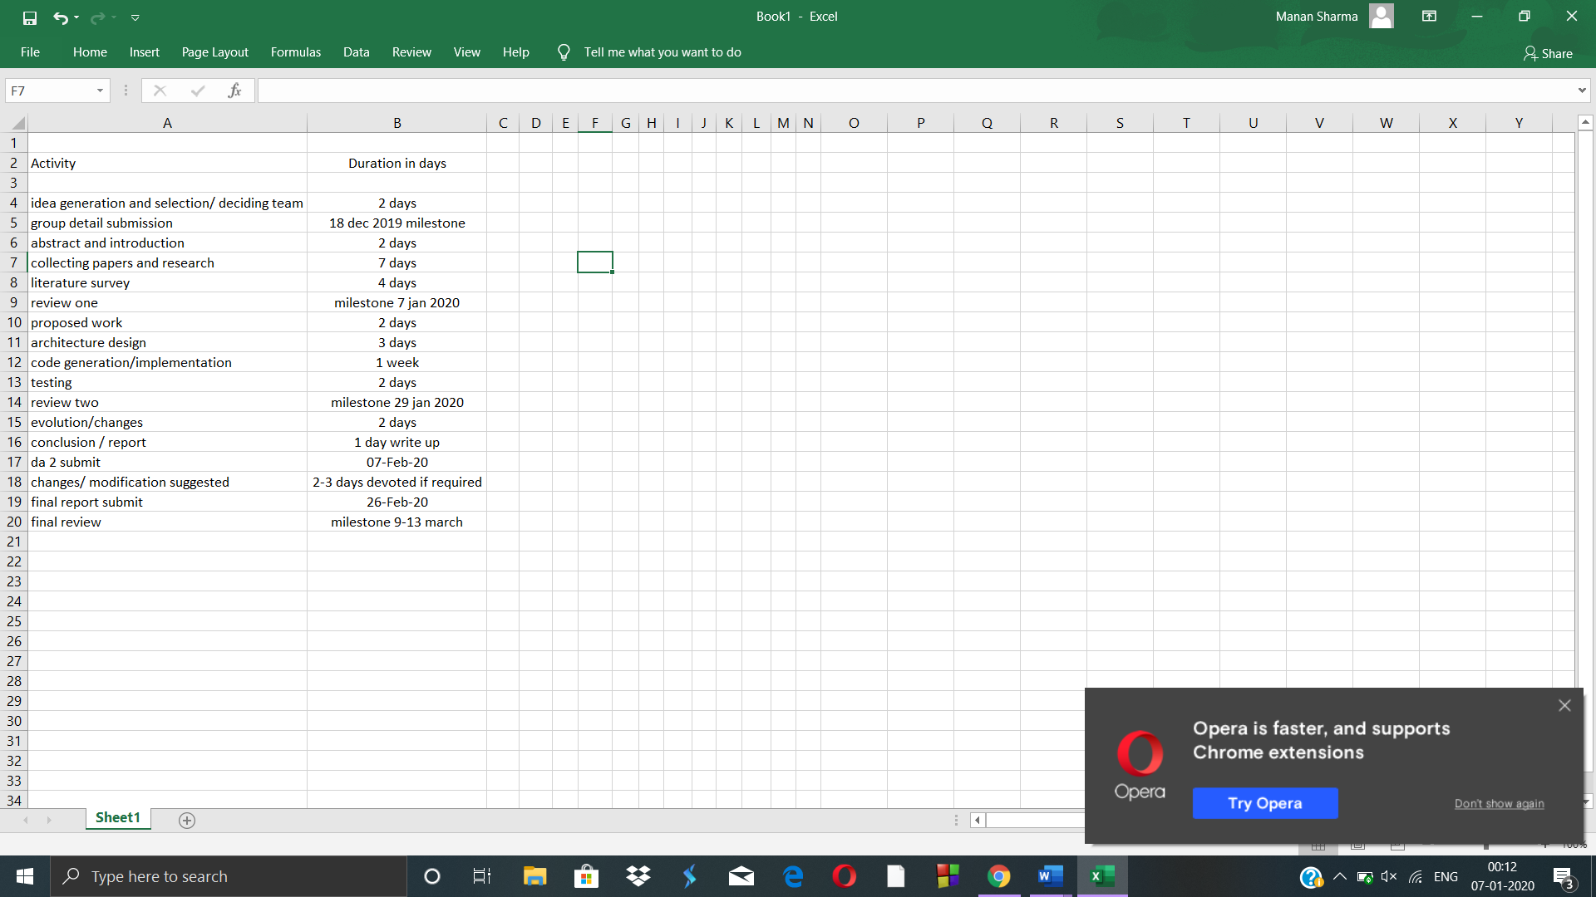

***WORK ALREADY DONE:***

**Plan of action**

• MendIT is a new friendly and fun place that offers everything for a dollar or less. It is a great place to visit and everyone leave happy without leaving broke.

• At MendIT we employee several measures to insure a steady flow of revenue.

• We will have a very nominal fee from the worker as well as the employer uses our platform to post an advertisement for a job posting. We will have advertisements on our app to make money.

• Even after that we will use investors’ money to make profit. Even different companies can approach to provide services on behalf of their company, and we can charge for that services. It is great platform to give jobs, we have job section in which anybody can provide its resume and get job opportunities. And even we can charge for that too. House selling and different opportunities will be provided in the near future.

**Competitors**

1. Justdial is an Indian based company that provides search services and is made available on Website and Mobile. It also provides the user with the details of all the service providers. The customers are required to call a hotline number and ask the operator what service they are looking for (e.g., restaurants, hospitals, banks etc.) and in which area. In turn the operator will send them an email and an SMS with the information. Apart from this, customers can search for the information of any specific business on the Website and Mobile Application.

2. INDIAMART InterMESH Ltd. is an Indian e-commerce company that provides B2C, B2B and customer to customer sales services via its web portal. The group began in 1996 when Dinesh Agarwal and Brijesh Agrawal founded the website IndiaMART.com, a business-to business portal to connect Indian manufacturers with buyers. The company is headquartered in Noida, Uttar Pradesh, India. Over the last 10 years, IndiaMART has become the largest e-commerce platform for businesses with about 60% market share.

3. Sulekha: Sulekha is a digital platform for local service businesses in India, matching 20+ million consumers with 50,000 service professionals across 200 categories in about 40 cities. Sulekha focuses on expert services clustered around Home, Life and Self and where the user need is customized. Using technology and domain intelligence, the platform seeks to understand the user need in detail and matches it to verified service professionals who are profiled. The service is free to use for consumers and service professionals pay the platform for performance in the form of verified, matched service requests.

**• Vision Statement**

1. To be the company that best understands and satisfies the services and product and fulfilment of the required homeowners as well as better job organization in the-today-unorganized skilled and unskilled workforce handymen.

2. Introducing the not so tech-savvy to the internet while providing them a way to increase their income while also becoming the voice of the supressed.

• **Mission Statement**- Our aim is to inject technology, accessibility and professionalism to the working force by creating a curated platform for unorganized services and a reliable high-quality service at people’s doorsteps.

***MOTIVATION BEHIND THE PROJECT:***

In daily life, a layman deals with different transaction in terms of selling and purchasing of goods and services. In these transactions the second one persuades the first person. Therefore, selling may be defined as persuading people to satisfy the want of first one. The person, who does this act, is called as the salesman, the result of this action as sales, while these activities of the person, are supervised and controlled by sales-management. In the present scenario sales executives are professionals. They plan, build and maintain effective organizations and design and utilize efficient control procedures. The professionals approach requires thorough analysis, market-efficient qualitative and quantitative personal-selling strategy. It calls for skilful application of organizational principles to the conduct of sales operations. In addition, the professional approach demands the ability to install, operate, and use control procedures appropriate to the firm’s situation and its objectives. Executives capable of applying the professional approach to sales management are in high demand today. The quality of selling is referred to as salesmanship. In other words, ‘management’ is synonymous with leadership. Managers do the same thing in industry, as ministers do in states and at the center, i.e., they have to plan, forecast, direct and control their personnel. Here success lies in running together, hand in hand. Managers are the captains of the army of their followers. This web application hence will help us mediating between employers and employees.